**To have VCS option on main menu**

Step 1: File -> Settings

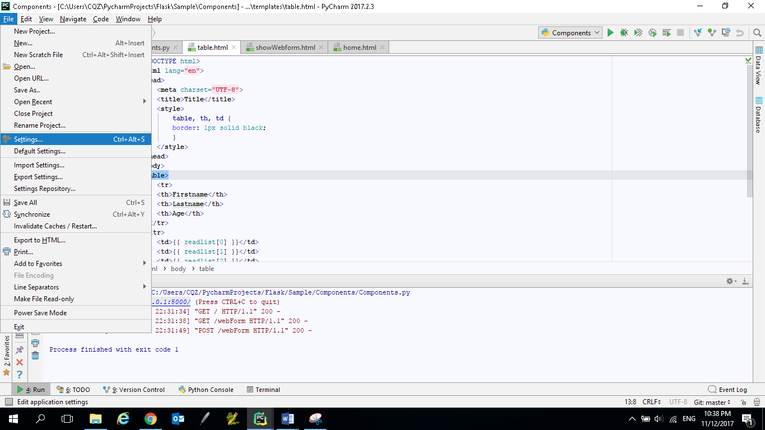

Step 2: Appearance & Behavior -> Menus and Toolbars -> Click on ‘**Restore All Defaults**’

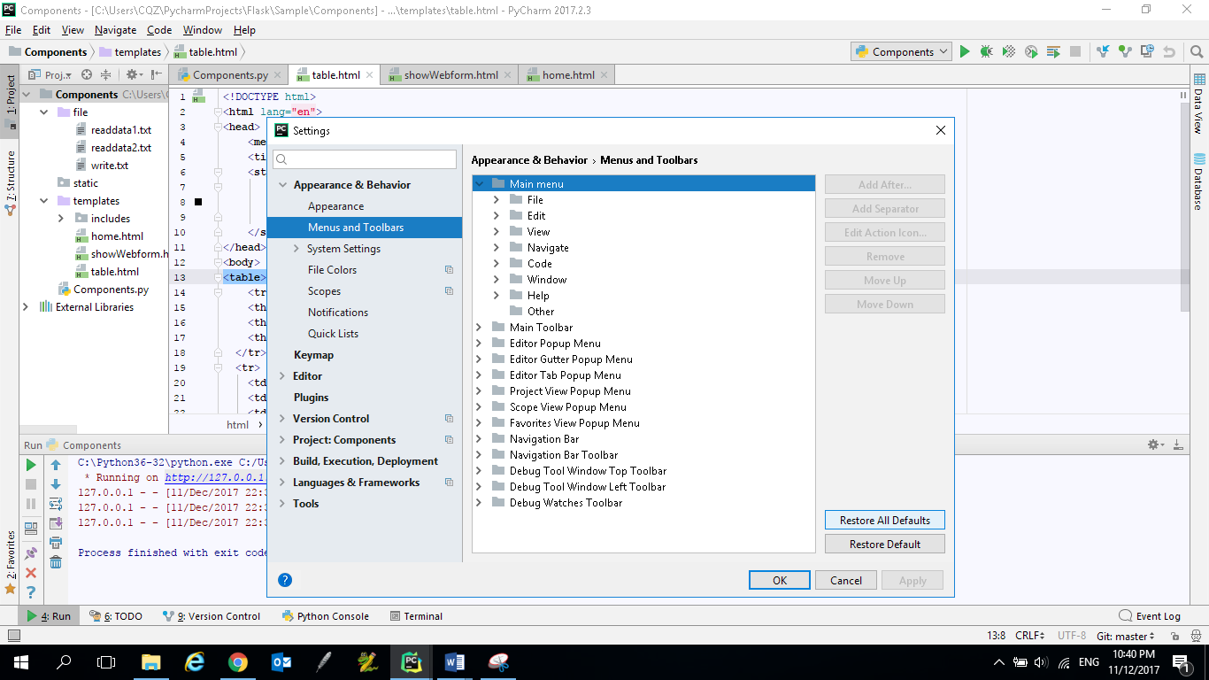

Step 3: After step 2, the **VCS** option will be shown under the **Main Menu**. Click **OK**.

